**Course Name: Analog Communication**

**MATLAB Experiment-4**

**Objective** – Write MATLAB code to study *linear and time invariance* properties of an LTI system for *x(t*) and *h(t)* with the value 1 ranging from **t=-1** and **t=1**

**MATLAB Code:**

t = -5:0.01:5; % input

X = @(t) (t>=-1 & t<=1);

H = @(t) (t>=-1 & t<=1);

Y = @(t) conv(X(t) , H(t)); % output

S = @(X) conv(X , H(t));

a1 = 2; a2 = 3; % amplitude given by user

t = -5:0.01:5;

x1 = a1.*X(t);

x2 = a2.*X(t);

subplot(1,2,1);

plot(S(x1+x2));

title('S(a1*x1(t) + a2*x2(t))');

y1 = a1.*Y(t);

y2 = a2.*Y(t);

subplot(1,2,2);

plot(y1+y2);

title("a1*y1(t) + a2*y2(t)");

figure;

T = 4;

subplot(1,2,1);

YT = conv(X(t - T) , H(t));

plot(YT);

title("Y(t-T)");

subplot(1,2,2);

plot(S(X(t-T)));

title("S(x(t-T))");

**Result:**

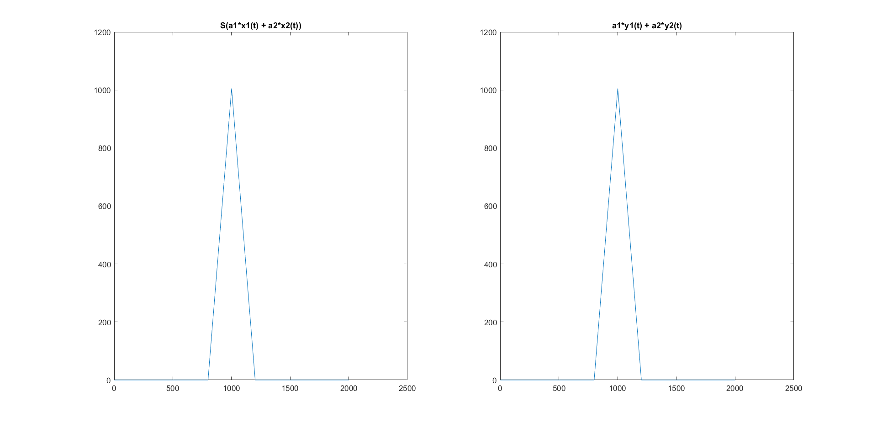Graph 1:

Inference: Both graphs are similar so function Y(t) = X(t) should be linear.

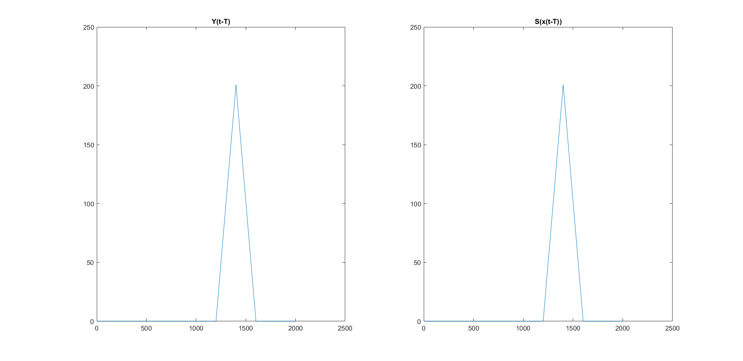 Graph 2:

Inference: Both the graphs are similar, means Y(t) = X(t) must be time invariant.